Ex.1

In BCNF, every non-prime attribute should be functionally dependent on any of super key in schema. If there exists any FD, which do not follow this, then for that case we have to separate it into new relation. Now if any of other FD uses previous FD, Then this creates non-preservation of FD in BCNF.

Example:

Consider the following schema:

a b c and c->b

Clearly the above schema is in 3NF, because ab->c is a superkey dependency and, from c->b we can see that b-c=b, which is a subset of the primary key (such dependency is also allowed in3NF). But, the above schema is not in BCNF because c->b is neither super-key nor trivial dependency. So we decompose above schema, keeping it lossless. Only possible lossless decomposition is ac and cb (because, their intersection c is primary key for the 2nd table). But, clearly the dependency ab->c is lost.

Ex.2

or

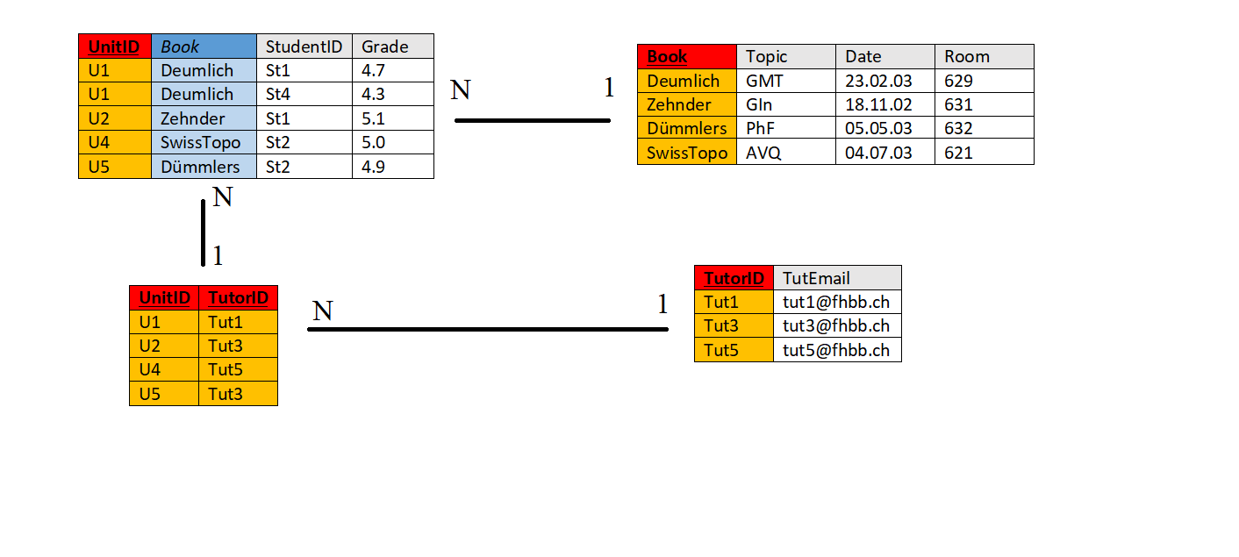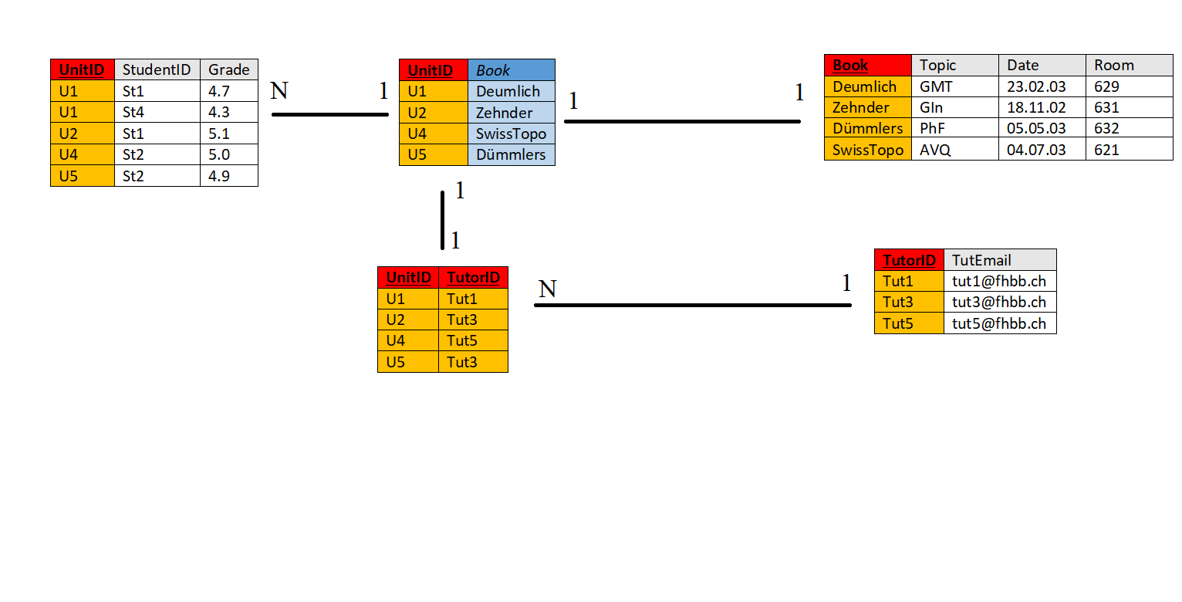

Ex.3

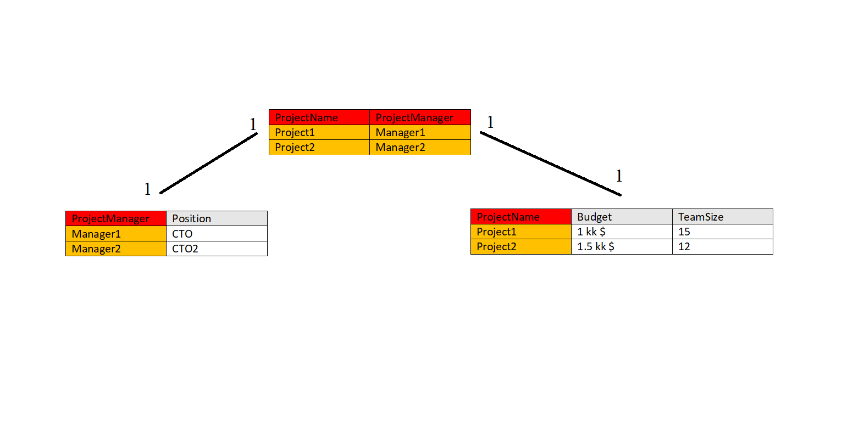

Ex.4

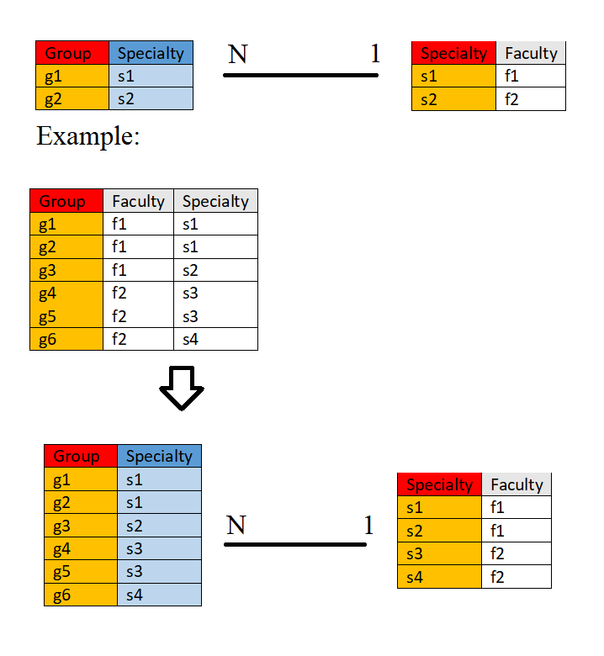

Ex.5

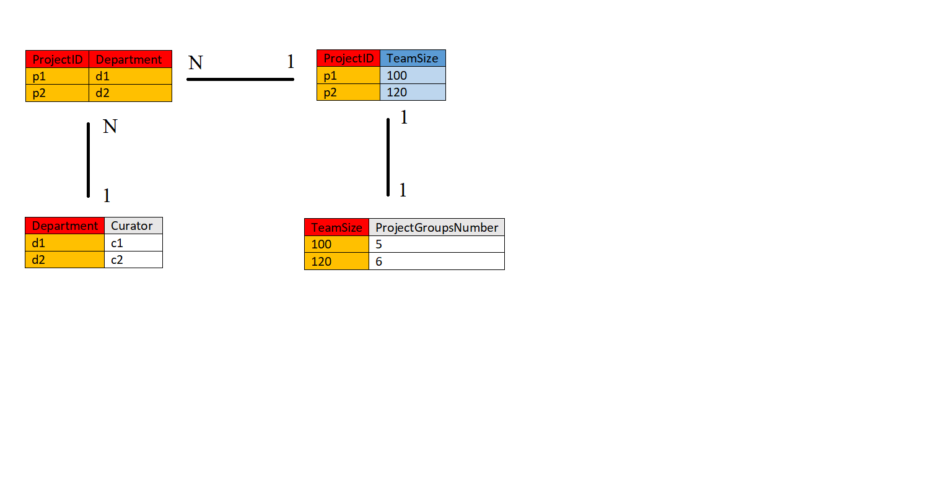

Ex.6

The three design goals are lossless-join decompositions, dependency preserving decompositions, and minimization of repetition of information. They are desirable so we can maintain an accurate database, check correctness of updates quickly, and use the smallest amount of space possible.

Desirable: when you break down one table into multiple tables and the join results in the same original relation.

Undesirable: when you break down one table into multiple tables and the join results different from the original relation.